SDC Vol 2 No 443 Fol 5-8 Grant to Benjamin Sweetland 22-05-32 transcribed

Transcribed by Kevin Reddigan

No. 443

Newfoundland.


WILLIAM the Fourth by the
Grace of GOD of the United Kingdom of Great
Britain and Ireland King Defender of the Faith
R. A. Tucker
President & Actg. Governor
To all to whom these Presents shall come, Greeting:

KNOW ye that We of our special grace
certain knowledge and mere motion have given and granted and by these Presents
do for Us our heirs and successors Give and Grant unto Benjamin
Sweetland of Caplin Bay in our
Island of Newfoundland
Merchant_______________________________________________

his heirs and assigns all that piece and parcel of Land situate and being
Fees | Stg.
Great Seal | 5.0
Secretary | 7.0
Surveyor | 7.0
Dep^{y} Surveyor | 7.0
 | £16.0

at Caplin Bay aforesaid and lying
about a quarter of a mile from the
Sea shore bounded on the east west
and North sides by unclaimed and
uncultivated ground and on the
South partly by a Pond and partly
by a Field the Property of the said
Benjamin Sweetland

in our Island of Newfoundland bounded as the same is delineated and described
in
in the diagram hereunto annexed and containing Twenty Seven Acres
One Rood and Twenty Nine Perches

with appurtenances except and reserved nevertheless out of this present
Grant to Us our heirs and successors all Gold and Silver and all Coals and other
Mines and Minerals in or under the said piece or parcel of Land.
To Have and to Hold (except as before excepted) unto the said
Benjamin Sweetland
his heirs and assigns for ever he the said Benjamin
Sweetland_________________________________
his heirs or assigns yielding and paying therefore yearly and every year for
ever unto Us our heirs and successors at the Office of the Secretary of our Go-
vernor of our said Island for the time being in the Town of St. John's in our
said Island of Newfoundland or to such other person as shall be appointed to
receive the same yearly Rent or Sum of Sixpence_______________
____________________________Sterling Money of our said United
Kingdom for each and every Acre of the said Land hereby granted to
commence on the 24th day of June which shall be next after the expiration of
Two Years from the day of the date hereof and to be paid yearly and every year on the 24th day of June for ever. And in default of the said payment or if it shall
happen that the aforesaid yearly Rent shall be at any time behind and unpaid in
the whole or in part by the space of Thirty Days next after any day whereon the
same ought to be paid as aforesaid then and from thenceforth this Grant shall
immediately cease and determine and be void and of non effect and the said Land
and Appurtenances shall revert to and revest in Us our heirs and successors.
Provided always and this present Grant is upon condition that One Fifth
part or portion of the Land hereby granted shall be properly cleared cleansed
and cultivated within the period of Three Years next ensuing after the day on
which Rent shall first become due and payable under the provisions of this Grant. Provided also and this present Grant is also upon condition that the same Grant
be registered in the Office of Registry of our Southern District Court of
Newfoundland within Three months next after the day of the date hereof
or otherwise that the same shall be void and of non effect. Provided also
and this present Grant is upon condition that the said Lands shall be holden
upon under and subject to such regulations as may at any time hereafter be made
by Law for the improvement and cultivation of Lands within our said Island of
Newfoundland and subject to all such regulations as may at any time hereafter be
made by Law for making Roads Sewers Drains Canals Bridges or other Public
Works or Improvements within our said Island of Newfoundland or any part
thereof and for subjecting any Lands therein situate or the owners or occupiers of
such Lands to rates and assessments or other duties or services for the purposes aforesaid or for any of them. And that the said Benjamin
Sweetland his heirs and assigns shall at all times
peaceably quit and deliver possession to Us our heirs and successors of all such
parts of the Lands aforesaid as may be required for the purposes aforesaid or any
of

of them receiving such compensation (if any) as by any Law hereafter to
be made in that respect may be provided.

Given under the Great Seal of our Island of Newfoundland
at St. John's this Twenty second day of May
in the Year of our Lord One Thousand Eight Hundred and
Thirty Two and in the Second Year of our Reign.

Witness our trusty and well-beloved Richard
Alexander Tucker Esq. President of our
Council of our said Island. Administering
the Government of
our said Island and its Dependencies &c.

By His Honors Command
James Crowdy
Secretary

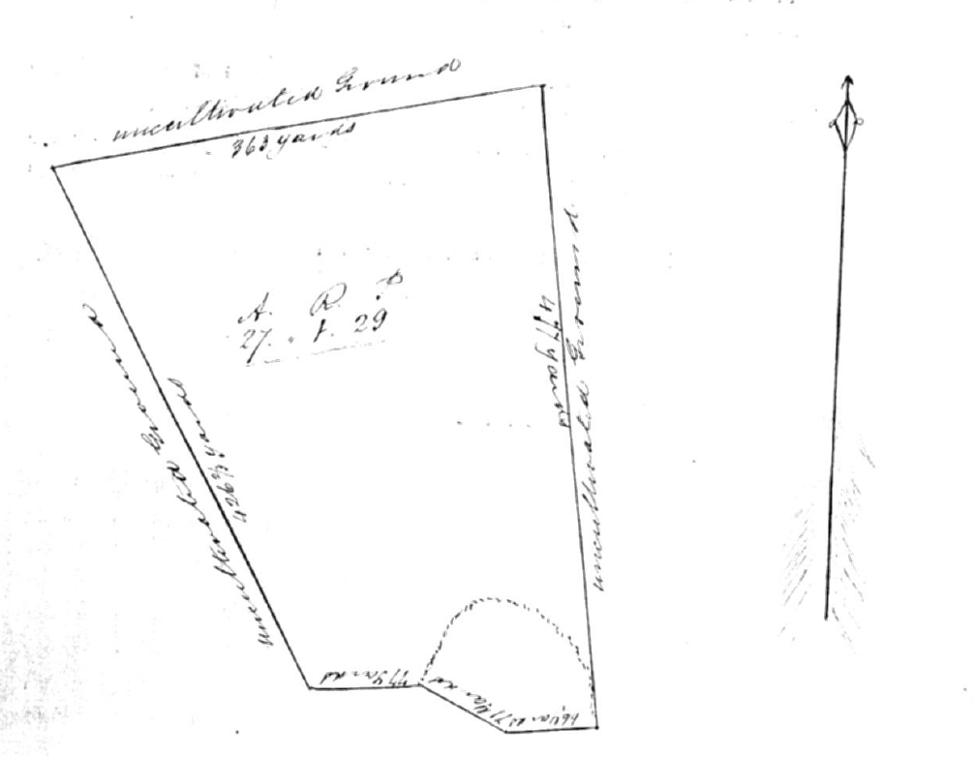
I certify that the above Grant
No. 443 was Registered by me this
Twenty First day of July one thousand
eight hundred and thirty two.
Southern District B.G. Garrett
Registration Office Reg^{r.}
Ferryland 21st July 1832

