SDC Vol 2 No 602 Folio 279-282 Grant to William Goff 9-10-1847
Editorial Note: Much of the text in these grants is boiler plate with the particulars of the piece of land being handwritten in the appropriate places. To distinguish between the boiler plate and the specific details of the transaction the latter are shown in italics.
No. 602
Newfoundland
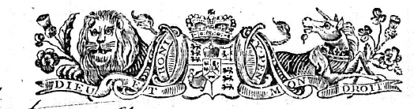
J. Gaspard Le Marchant
{L.S.}

WILLIAM the Fourth ^^{Victoria} by the
Grace of GOD of the United Kingdom of Great
Fees | Stg.
Great Seal
Secretary
Surveyor
Dep^{y} Surveyor

Britain and Ireland King ^^{Queen} Defender of the Faith

To all to whom these presents shall come Greeting

KNOW ye that WE of our special grace
certain knowledge and mere motion have given and granted and by these Presents
do for Us our heirs and successors Give and Grant unto William
Goff of St. John’s in our Island of Newfoundland

his heirs and assigns all that piece and parcel of Land situate and being
on the North side of Ferryland bounded as follows, that is to say, by a line
commencing at a point on the shore of Caplin Bay whence cold east pt. bears
South forty two degrees and thirty minutes east thence abounded by the said Caplin Bay and extending
along the shore in a South Easterly direction four chains and seventy five links more or less to the said point
thence bounded by the shore of Ferryland Harbour and running south westerly eleven chains and ninety links thence westerly
along the said shore five chains and forty five links thence north twenty three degrees forty five minutes east sixty five links thence
bounded by a public path separating the land herein described from land occupied by Elizabeth Holdsworth and extending thereby
in a NE direction five chains and thirty links thence north thirty nine degrees East two chains and fifty links thence North thirty one
degrees West one chain forty five links thence North forty seven degrees thirty minutes East twenty eight links thence South seventy six degrees
forty five links thence in an irregular line NE one chain thence North forty four degrees East four chains and forty links more or less to the place
of commencement containing three Acres two Roods and five Perches more or less as shown in the diagram No 1 on the other side hereof. Also
that other piece of land situate at Ferryland aforesaid and lying on the north west side of the Sun Hill Road abutted and bounded as
follows that is to say by a line commencing at a point on the said Road at the NE angle of land in the possession of Martin Culleton
thence bounded by the said Culleton’s land and running by the magnet in 1847 north sixty four degrees thirty minutes west three
chains forty links more or less to land in the possession of Robert Carter thence bounded by the said Carer’s land in an irregular line
NE one chain twenty eight links more or less to a Public road thence following the direction of the said Road south easterly
two chains and fifty five links more or less thence bounded by the said Sun Hill Road South thirteen degrees West one chain
and twenty nine links more or less to the place of commencement containing one Rood and twenty two perches more or less
as shown in the above Diagram No 2 on the other side hereof. Also all that other piece or parcel of land situate and being
at Ferryland aforesaid abutted and bounded as follows that is to say on the Northward by land in the possession of James
McGee one chain fifty five links on the Eastward by the Cornfield Road extending thereby two chains on the Southward
by land in the possession of Martin Culleton one chain eighty links and on the Westward by land occupied by James
Murphy two chains and five links containing one Rood and fourteen perches more or less as shown in the
Diagram No 3 on the other side hereof

in our Island of Newfoundland bounded as the same is delineated and described
in
and being of the dimentions [sic] specified on the diagram delineated on the other
side hereof.

In the diagram hereunto annexed and containing in the whole four acres one Rood and
one perch more or less.

with the appurtenances except and reserved nevertheless out of this present
Grant to Us our heirs and successors all Gold and Silver and all Coals and other
Mines and Minerals in or under the said piece or parcel of Land.
To Have and to Hold (except as before excepted) unto the said

William Goff
his heirs and assigns for ever he the said William Goff paying onto us as the price and consider-
ation of the said land the sum of five shillings sterling money at the time of the ensealing and delivery
hereof.

heirs and assigns yielding and paying therefore yearly and every year
for ever unto Us our heirs and successors at the Office of the Secretary of our Go-
Ex^{d.} Nov. 1 1847
E. M. Archibald
H. M. Atty. Genl.
vernor of our said Island for the time being in the Town of St. John’s in our
said Island of Newfoundland or to such other person as shall be appointed to
receive the same the yearly Rent or Sum of
Sterling Money of our said United
Kingdom for each and every Acre of the said Land hereby granted to
commence on the 24th day of June which shall be next after the expiration of
Two Years from the day of the date hereof and to be paid yearly and every year
on the 24th day of June for ever. And in default of the said payment or if it shall
happen that the aforesaid yearly Rent shall be at any time behind and unpaid in
the whole or in part by the space of Thirty Days next after any day whereon the
same ought to be paid as aforesaid then and from thenceforth this Grant shall
immediately cease and determine and be void and of non effect and the said Land
and Appurtenances shall revert to and revest in Us our heirs and successors.
Provided always that and this Grant is upon condition that
part or portion of the Land hereby granted shall be properly cleared cleansed
and cultivated within the period of Three Years next ensuing after the day on
which Rent shall first become due and payable under the provisions of this Grant.
Provided also and this present Grant is upon condition that the same Grant
be registered in the Office of Registry of our Southern District Court of
Newfoundland within Three months next after the day of the date hereof
or otherwise that the same shall be void and of non effect. Provided also
and this present Grant is upon condition that the said Lands shall be holden
upon under and subject to such regulations as may at any time hereafter be made
by Law for the improvement and cultivation of Lands within our said island of
Newfoundland and subject to all regulations as may at any time hereafter be
made by Law for making Roads Sewers Drains Canals Bridges or other Public
Works or Improvements within our said Island of Newfoundland or any part
thereof and for subjecting any Lands therein situate or the owners or occupiers of
such Lands to rates and assessments or other duties or services for the purposes
aforesaid or for any of them. And that the said William Goff
his heirs and assigns shall at all times
peaceably quit and deliver up possession to Us our heirs and successors of all such
parts of the Lands aforesaid as may be required for the purposes aforesaid or any
of
of them upon receiving such compensation (if any) as by any Law hereafter to
be made in that respect may be provided.
Given under the Great Seal of our Island of Newfoundland
at St. John’s this ninth day of October
in the Year of our Lord One Thousand Eight Hundred and
Thirty Forty seven and in the eleventh Year of our Reign.

Witness our trusty and well beloved Sir John Gaspard Le Marchant
Knight and Knight Commander of the Order of Saint Ferdinand and of Charles the third
of Spain our Governor and Commander in Chief in and over
our said Island and its Dependencies &c.
By His Excellency’s Command
Ja^{s.} Crowdy
Received the day and year above written from the within named Grantee
the sum of five shillings being the full amount of the consideration money herein
mentioned. Ja^{s.} Crowdy
£0.5.0 Secretary

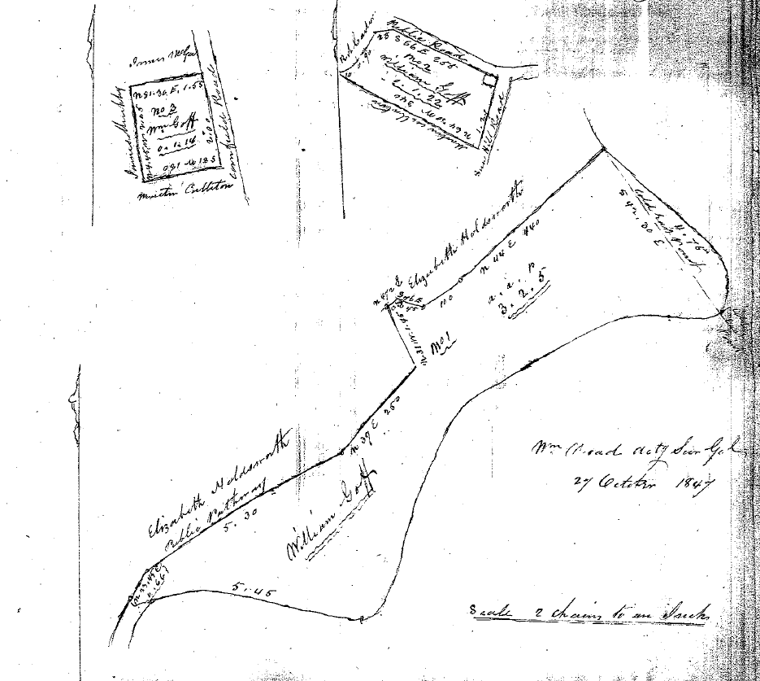

I do hereby Certify that the foregoing Grant of Land
Number 902 to William Goff of St. John’s was duly
Registered by me this Twenty second day of December
One thousand eight hundred and forty seven.
George Simms, Registrar

