SDC Vol 6 Fol 37-39 Grant to William and Michael Devereaux 29-08-1890
Editorial Note: Much of the text in these grants is boiler plate with the particulars of the piece of land being handwritten in the appropriate places. To distinguish between the boiler plate and the specific details of the transaction the latter are shown in italics. There is a notation at the top of each page: “SCANNED COPY 10007037 PID” indicating that this grant at least has already been scanned and needn’t be copied from the original old volumes.

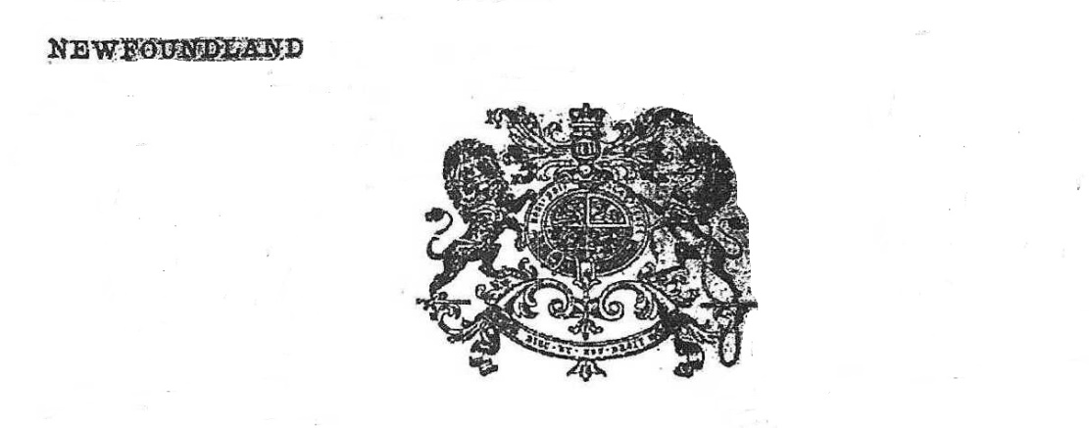

Victoria, by the Grace of GOD of the United
Kingdom of Great Britain and Ireland
Queen, Defender of the Faith
Sgd. J. O’Brien Lt. Col.
Govr.
To all to whom these presents shall come, Greeting

Sgd. P. Morris
H.M. Actg. Atty. Genl.
KNOW ye, that WE, of our special Grace, Certain Knowledge and Mere
Motion, have given and granted, and by these presents do, for Us, our Heirs and
Successors, GIVE and GRANT unto William Devereaux and
Michael Devereaux of Ferryland ______________________________________
in our Island of Newfoundland ____________________their heirs and successors
all that Piece and Parcel of Land situate and being on the
North side of Ferryland aforesaid, abutted and bounded
as follows, that is to say by a line commencing
at a point being the South West angle of the
land herein described, running thence by
James Culletan’s land North thirty degrees
East four chains and thirty links and South
seventy five degrees East four chains and
forty seven links more or less, thence by Reverend
L. Vereker’s land South thirteen degrees West
five chains more or less and thence by Robert
Farrell’s land North sixty three degrees West
six chains more or less to the place of
Commencement __________________________

And being of the dimensions specified in the diagram delineated on the other side hereof and containing Two acres
one Rood and Thirty three perches more or less______________________________________________________
with the appurtenances, except and reserved, nevertheless, out of this present Grant, to Us our Heirs and Successors,
all Gold and Silver and all Coals and other Mines and Minerals, in or under the said Piece or Parcel of
Land. To have and to hold (except as before excepted) unto the said William Devereaux and
Michael Devereaux their Heirs and Assigns under terms
and conditions of Section qw of the “Crown Lands Act 1884”, as
follows: “Every such Grant shall be upon the condition that
the grantor shall within five years from the date of the Grant
bona fide clear and cultivate ten acres for every one hundred
acres comprised in the Grant and in the same proportion for
any less quantity they the said William and Michael Devereaux

paying unto Us, as the price and consideration of the said Land, the Sum of One
Dollars _______________ Cents, at the time of the ensealing and delivery hereof.

for ever they the said James Devereaux, John Devereaux
and Michael Devereaux paying onto us as the price and consideration of the said land
the sum of six shillings Sterling money at the time of the ensealing and delivery hereof.

Provided always, and this present Grant is upon the further condition, that the said Lands shall be
holden upon, under, and subject to such regulations as are now in force, or which may at any time hereafter be made
by Law, for the improvement and cultivation of Lands within Our said island, and subject to all Regulations as
are now in force, or which may at any time hereafter be made by Law, for making Roads, Sewers, Drains, Canals,
Bridges, or other Public Works or Improvements, within our said Island, or any part thereof, and for subjecting any
Lands therein situate, or the owners or occupiers of such Lands. to rates and assessments. or other duties or services,
for the purposes aforesaid, or for any of them. And that the said William Devereaux and
Michael Devereaux ____________________________________________________________________________
their Heirs and Assigns, shall, at all times, peaceably quit and deliver up possession to Us, our Heirs and
Successors, of all such parts of the Lands aforesaid as may be required for the purposes aforesaid, or any of them. upon
receiving such compensation (if any) as by any Law now in force, or hereafter to be made, in that respect, may be
provided. And it is further provided that in case the said William Devereaux and Michael
Devereaux ___________________________________________________________________________________
their Heirs and Assigns shall make default in the performance of any of the provisions or conditions herein
contained, then this Grant shall be null and void and the hereby granted shall revert to Us, Our
Heirs and Successors.

Given under the Great Seal of Our aforesaid Island of Newfoundland, at
St. John’s, in Our said Island, this twenty ninth day of
August in the Year of Our Lord One Thousand
Eight Hundred and Eighty Ninety and in the
Thirty fourth Year of Our Reign.

Witness Our trusty and well beloved Lieutenant Colonel Sir J. Terence
L. O’Brien Knight Commander of the Most
Distinguished Order of St. Michael and
St. George, Governor and Commander-in-Chief
in and over our said Island of Newfoundland and its Dependencies.

By His Excellency’s Command
Sgd. J. W. Withers
pro. Colonial Secretary.

Received, the Day and Year above written, from the within named Grantee the Sum of
One Dollar______________________________________________________
amount of the Consideration Money of the Land herein granted.
_______
$1.00 H. M. Surveyor General
=======

Registered Volume, No. 42 Folio 38

